IGS-5508
Unmanaged GbE Switch

Quick Installation and
Initial Configuration

Contents
Chapter 1 Introduction 1
Overview 1
Front View of the Switch 1
Rear View of the Switch 2
Bottom View of the Switch 2
LED Descriptions 3
Reset Button 4
Chapter 2 Installing the Switch 5
Package Contents 5
Mounting the Switch on a DIN Rail 5
Mounting the Switch on Wall (Optional) 6
Connecting the DC Power Cord 7
Chapter 3 Troubleshooting 9

Chapter 1 Introduction

Overview
This user guide describes how to install, configure, and troubleshoot the IGS-5508, 8 Ports Industrial unmanaged GbE Switch.
By reading this user guide, users can perform the following tasks:
- To check the switch status by reading the LED behavior
- To reset the switch
- To install the switch
- To troubleshoot the switch

Front View of the Switch

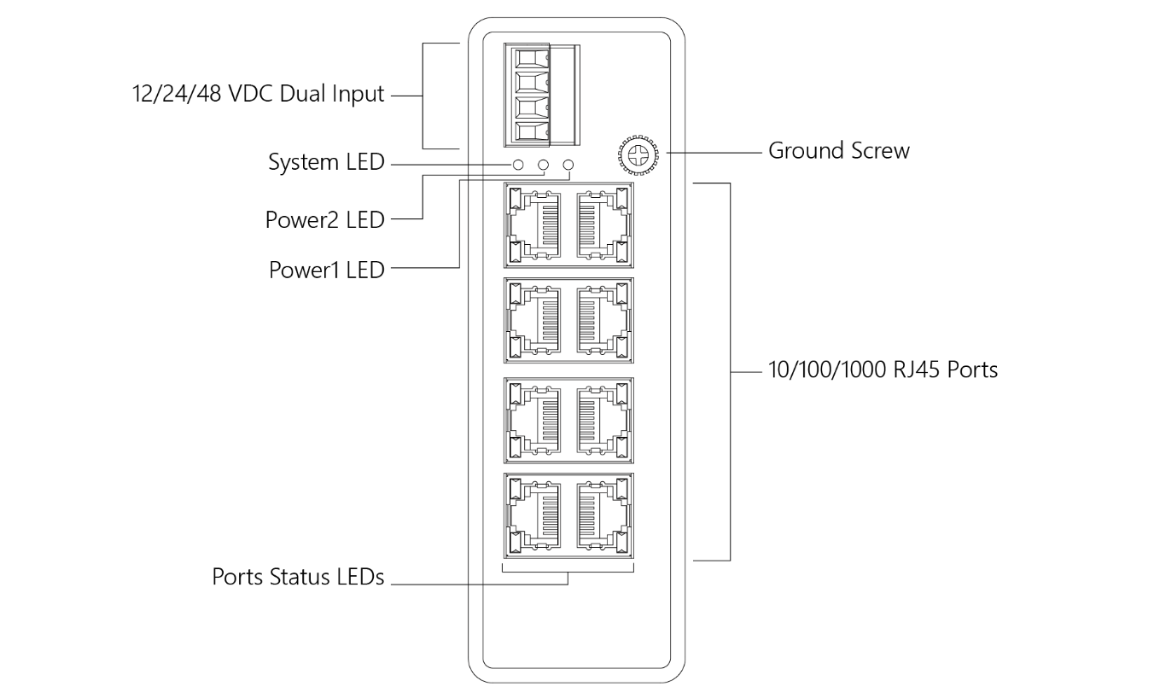
Figure 1: Front panel of the switch

Rear View of the Switch
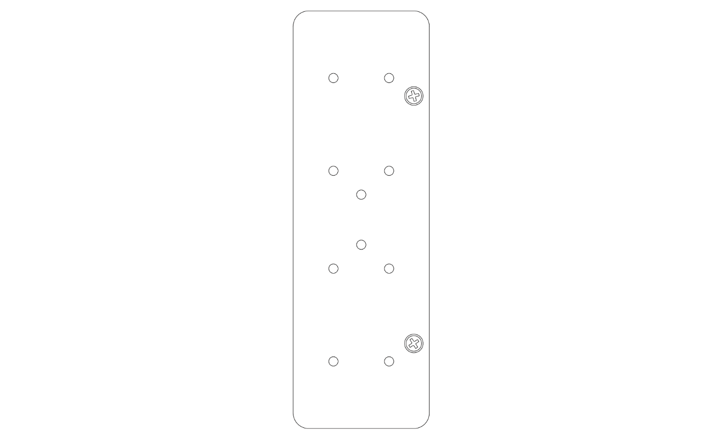
Figure 2: Rear panel of the switch

Bottom View of the Switch
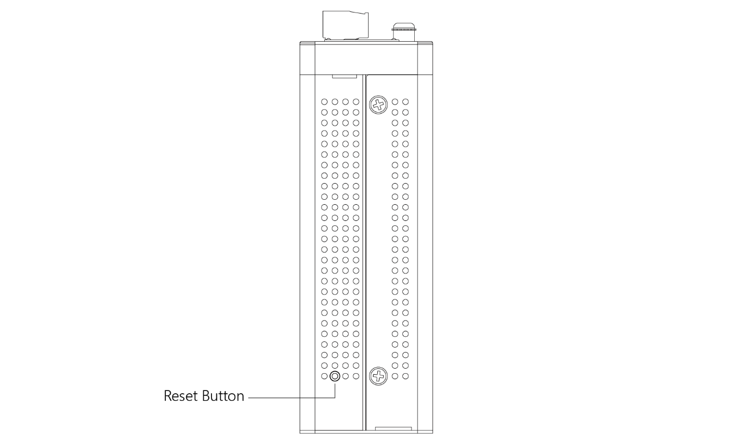
Figure 3: Bottom panel of the switch

LED Descriptions
The LEDs on the front panel provide users with switch status checking and monitoring. There are three types of LEDs as follows:
- Power LEDs
indicates if the switch is powered up correctly or not.
- System LED
indicates if the system is ready or not.
- Port Status LEDs
indicates the current status of each port. Users can check these LEDs to understand the port status.

The following table details the functions and descriptions of various LED indicators.
Table 1: Power LEDs
LED | Color | State | Description
Power1 | Green | On | The switch is powered ON correctly.
 |  | Off | The switch is not receiving power from power1.
Power2 | Green | On | The switch is powered ON correctly.
 |  | Off | The switch is not receiving power from power2.

Table 2: System LED
LED | Color | State | Description
System | Green | On | The switch is ready.
 |  | Off | The switch is not ready.

Users can check the port status by reading the LED behaviors per the table below.
Table 3: Port Status LEDs
LED | Color | State | Description
RJ45 Ports (Left Side) | Green | On | The port is enabled and established a link to connected device, and the connection speed is 1000Mbps.
 | Green | Blinking | The port is transmitting/receiving packets, and the connection speed is 1000Mbps.
 | Amber | On | The port is enabled and established a link to connected device, and the connection speed is 10/100Mbps.
 | Amber | Blinking | The port is transmitting/receiving packets, and the connection speed is 10/100Mbps.
 | -- | Off | The port has no active network cable connected, or it is not established a link to connected device. Otherwise, the port may have been disabled through the switch user interface.

Reset Button
By pressing the Reset Button for certain period of time, users can perform the following task.
- Reset the Switch
to reboot the switch.

Chapter 2 Installing the Switch

Package Contents
- The Switch
- Terminal Block
- Installation Guide
- Mounting kit

Mounting the Switch on a DIN Rail

Step 1: Attach the DIN Rail mounting kit to rear panel of the chassis. Insert screws and tighten then with a screwdriver to secure the kit.
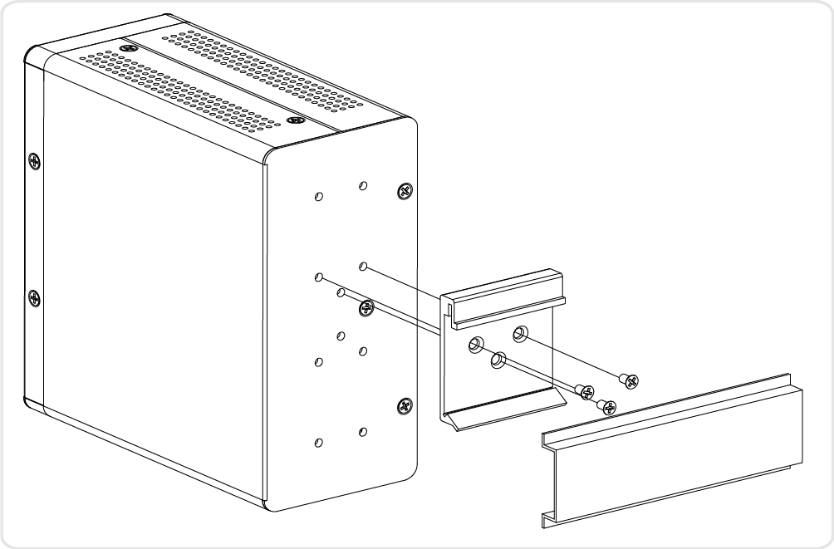
Figure 4: Attaching DIN Rail Kit to the Switch

Step 2: Insert the upper lip of the DIN rail into the DIN-rail mounting kit. And press the switch towards the DIN rail until it snaps into place.

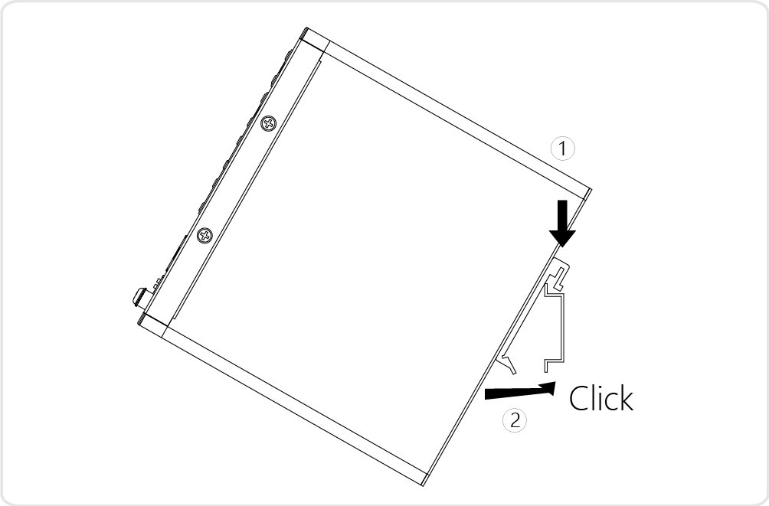
Figure 5: Insert switch to the DIN Rail

Step 3: Make sure that the switch is attached securely to DIN Rail.
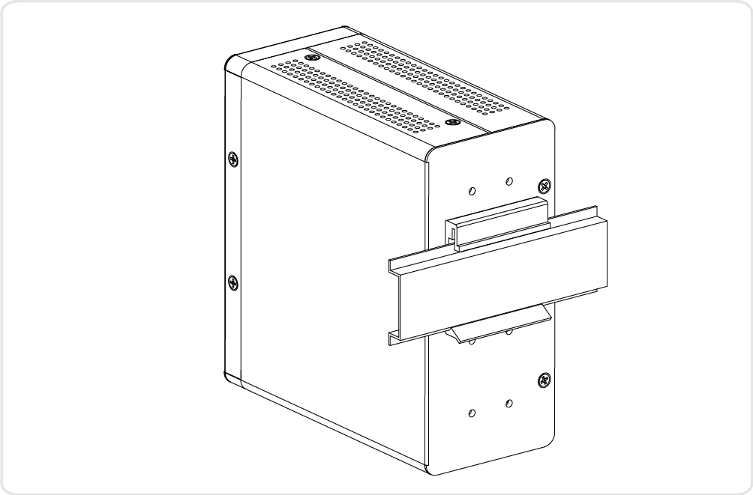
Figure 6: The switch is attached to DIN Rail

Mounting the Switch on Wall (Optional)
Step 1: Attach the wall mounting plates to rear panel of the chassis. Insert screws and tighten then with a screwdriver to secure the plates.
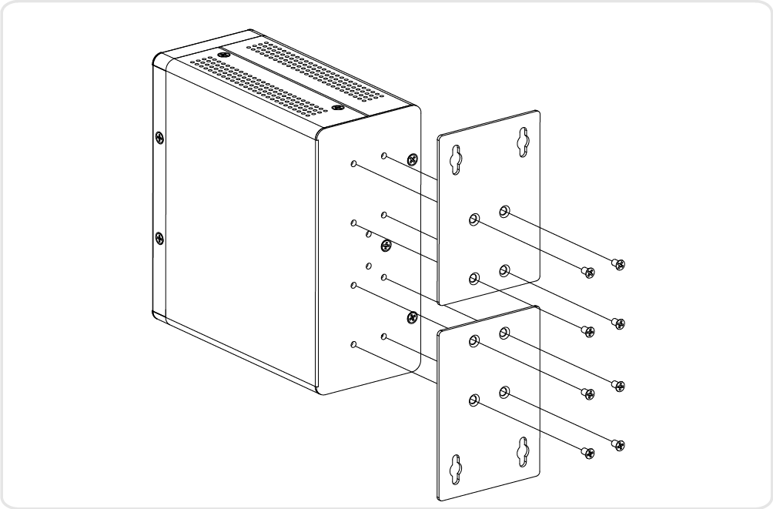
Figure 7: Attaching Wall Mounting Plates to the Switch

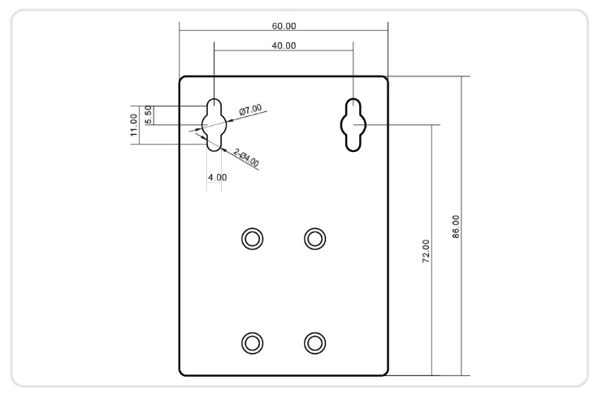
Figure 8: The Dimension of Wall Mounting Plates

Step 2: Install user-supplied screws on the appropriate location on the wall.
Step 3: Make sure that the switch is attached securely to wall.

Connecting the DC Power Cord
Step 1: Insert the negative/positive DC wires into the V-/V+ terminals, respectively.
Step 2: To keep the DC wires from pulling loose, use a small flat-blade screwdriver to tighten the wire-clamp screws on the front of the terminal block connector.
Step 3: Insert the terminal block connector prongs into the terminal block receptor.
Step 4: Check the SYS LED. If it is ON, the power connection is correct.

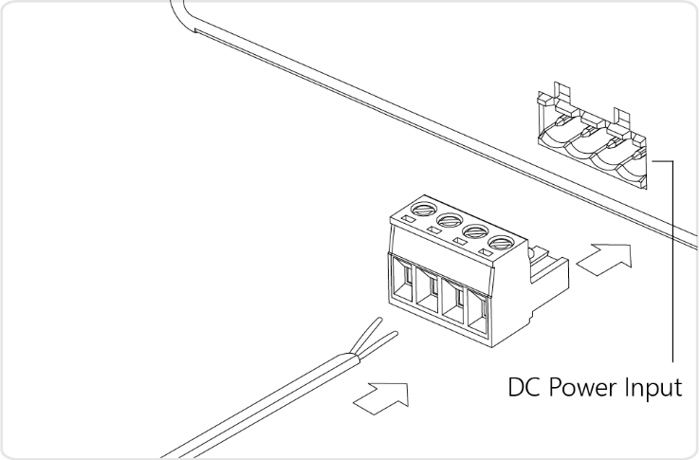
Figure 9: Connecting DC power cord

FAULT:
The two contacts of the terminal block connector are used to detect user-configured events. The two wires attached to the fault contacts form an open circuit when a user-configured event is triggered. If a user-configured event does not occur, the fault circuit remains closed.

Chapter 3 Troubleshooting
The following table provides information for users to easily troubleshoot problems by taking actions based on the suggested solutions within.
Table 4: Troubleshooting Table
Symptoms | Possible Causes | Suggested Solutions
System LED is Off | The switch is not receiving power. | 1. Check if correct power cord is connected firmly to the switch and to the DC outlet socket.  2. Perform power cycling the switch by unplugging and plugging the power cord back into the switch.  3. If the LED is still off, try to plug power cord into different DC outlet socket to make sure correct DC source is supplied.
Port (Left Side) Status LED is Off | The port is not connected or the connection is not working. | 1. Check if the cable connector plug is firmly inserted and locked into the port at both the switch and the connected device.  2. Make sure the connected device is up and running correctly.  3. If the symptom still exists, try different cable or different port, in order to identify if it is related to the cable or specific port.

